

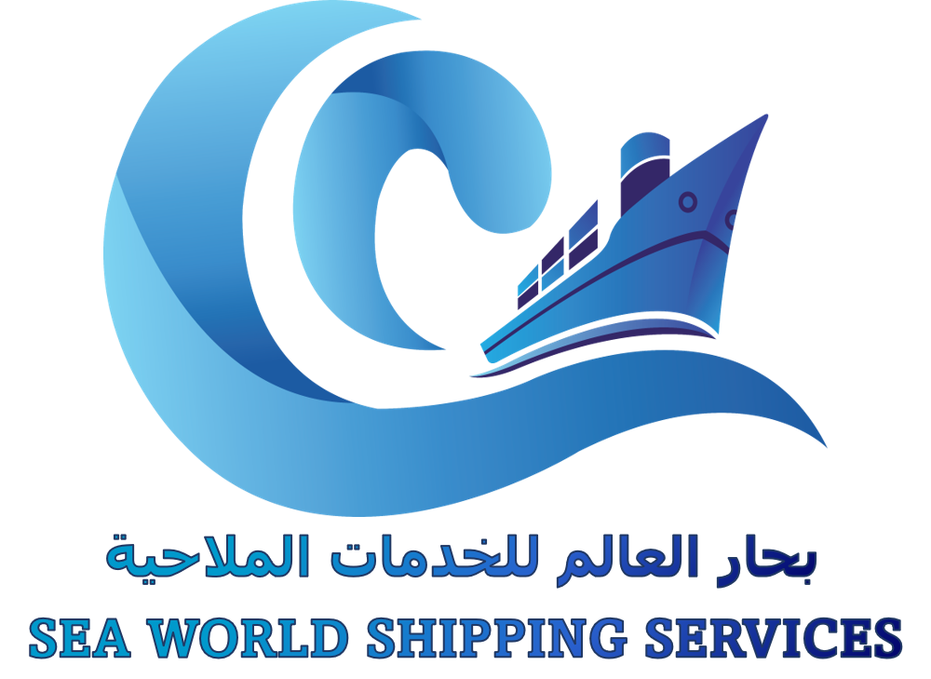



**Welcome to SWS Shipping**

SWSS is the organization that provides support services of all kinds to the Shipping industry.

All logistics solutions together with a comprehensive global freight forwarding service that provides solutions covering.



1. Air Cargo

2. Sea Cargo

3. Land Transportation

4. Vehicle Import & Export Service

5. LCL Service from/To all over the world

6. Break Bulk & Project Handling

7. Customs Clearance

8. Warehousing

9. Door To Door Cargo Services

To make these services stand out, SWSS includes ongoing investment in the skills of our staff and the latest in Information Technology. This includes in house ship agency management system

“TCL” (Transport Chain Link)



**About Us**

SWSS having a group experience of 20 years, our experienced management is committed to quality, reliability and innovation. Particularly emphasis on import and export of cargo enables us to expand and confirm our position as the Leading and Independent Operator.

SWSS, a diversified business conglomerates which has undergone rapid advancement since its inception. SWSS has steadily diversified its core activities by venturing into new business and continued to expand and successfully forged ahead in terms of revenue/turnover.

Logistics Headquartered in UAE, with centralized accounting systems. SWSS consists highly motivated and talented employees, striving hard to achieve unmatchable results. SWSS becomes an industry leader by fostering a strong relationship through building confidence in delivering unparalleled quality and service.



**Important Features**

SWSS has a network of multi-protocol and multi-standard communication platform in all its offices, as its logistics division offices being in UAE and Shipping partners with all over the world, The scope of the services develop in our centers has given these multi-nations opportunity to serve their clients in a better way and to progress in their goods ﬂow optimization process. Ensuring the quality SWSS services, its permanent commitment.

**Our Salient Features are**



Customs Clearance

De-Consolidation & Reloading

Performance and Long-Haul Cartridge Pickup & Delivery Assembly Service for Multiple Bill Of Lading

Correct Processing of Export

Declaration, Licenses & Shipping Documents



**Our Vision**

All major cities and industrial zones are connected through an efficient network Mode which connects the other cities and small towns with all over the world making them easily accessible as well ensuring a smooth How of raw materials required for various industries located in these cities. These passage ways also assist the transport of finished products to these ports which serves as a gateway for these places.

We believe in the future of shipping as the worldwide trade will gain an even bigger importance due to exceeding worldwide divisions of labour.

Also in future shipping and logistics will be a people's business. People are our focus. In shipping lines represented by us, our clients, our business partners and last but not least our employees.

This is the reason why we invest above average in education and further trainings of our employees.



**Break Bulk & Chartering**

Our chartering department always offers prompt and complete service. All inquiries are welcome and handle utmost attention.



SWSS chartering will find you tonnage and space for any kind of cargo bulk, general reefer, project cargoes or heavy lift cargoes.

SWSS chartering books cargo for company vessel and third parties and also act as Intermediary between shipper and ship owner's, keep us regular inform you and your Principal's vessel position and cargoes availability for worldwide transportation with attractive

freight and best workable terms to meet your all chartering

requirements very satisfactorily.

  



**Air Freight**

* With wide experience and expertise providing Air Cargo Division SWSS is proving itself a highly innovative

company and has introduced the modular concept of cargo handling.

Assuring you the most reliable economical and ﬂexible consolidation service, We at SWSS make arrangement with multi carriers and charterers with total airport to airport, airport to door, door to door operation with no matter of size. There are no weight limitation, full post ﬂight and proof of delivery information is faxed daily.

* Under the guidance of a progressive and maximum freedom to select the right Air Lines and create unique solution that benefit its customers even during peak seasons or under unexpected difficult circumstances. This is under lined by the fact that the executive heading of Air Freight division has more than 20 year’s experience in the Air Freight field.
* A sophisticated computer system linking the whole organization makes it possible for SWSS to offer clients detailed cost analyses of their expenditure. SWSS has developed its winning strong reputation for service excellence in terms of quality, reliability, speed and value of money.





**Ocean Freight**

* Our ocean freight experts around the world ensure that your cargo not only gets to its destination on-time, it gets the right treatment every step of the way.
* SWSS Provides A One Stop Center for all the needs in Exports-Imports Logistics Services. We are one of the leading names providing distinguished services to the clients all over the world. Our professionals are highly experience, educated and mature to provide most reliable and cost-effective solutions and

the highest level of customer service.





**Land Freight**

* Whether it is heavy or the size is big, or for that matter it is unconventional, professionals at SWSS can handle anything as far as land freight is concerned. We also ensure it arrives as per the committed schedule anywhere in the world. Titanium Cargo & SWSS offers land freight to most of the countries. We also have a specialized LTL service to different countries.
* SWSS’s professional transportation team, Assets and strong network is capable to meet customers various requirements. Our advance ﬂeet and experienced personal ensures safe and secure movement of goods. We are specialized in cross border, oversize dimension cargos, oil and gas, temperature controlled, Project Cargo Transportation etc. with our modern ﬂeet and rich experience of expertise, enable our truck services to deliver secure, cost effective and comprehensive services on time. We undertake back

loading of empty containers and local transportation for exporters and importers.

* We offer comprehensive door to door cargo handling services including stuffing, de stuffing, custom clearance, storage and transportation.



**LCL Service From/To All Over The World**

The Ocean Freight Management team of SWSS Shipping and Cargo Services LLC handles LCL Cargo movement from/to any global origin/destination - With its fully functional CFS and Supply Chain facilities, SWSS’s Ocean Freight Management capabilities have been rated among the best in the region.



IMPORT IMPORT

EXPORT

With our multi-country consolidation service, we can consolidate multiple LCL shipments from different shippers and origins into one full-container load. This gives you lower transit costs and fixed transit times using weekly sailings and smooth connections to the destination.





**Project Handling**

* We are also a specialist project forwarder handling parcel and project related traffic

throughout the world.

* We can cover each aspect of a through transport movemen and

our expertise can provide complete package incorporating break bulk, heavy lift, out of gauge, RORO and reefer and dry containers including the clients customs and documentation requirements. Taylor made solutions from point to point.



**UAE & GCC Transit**

* + 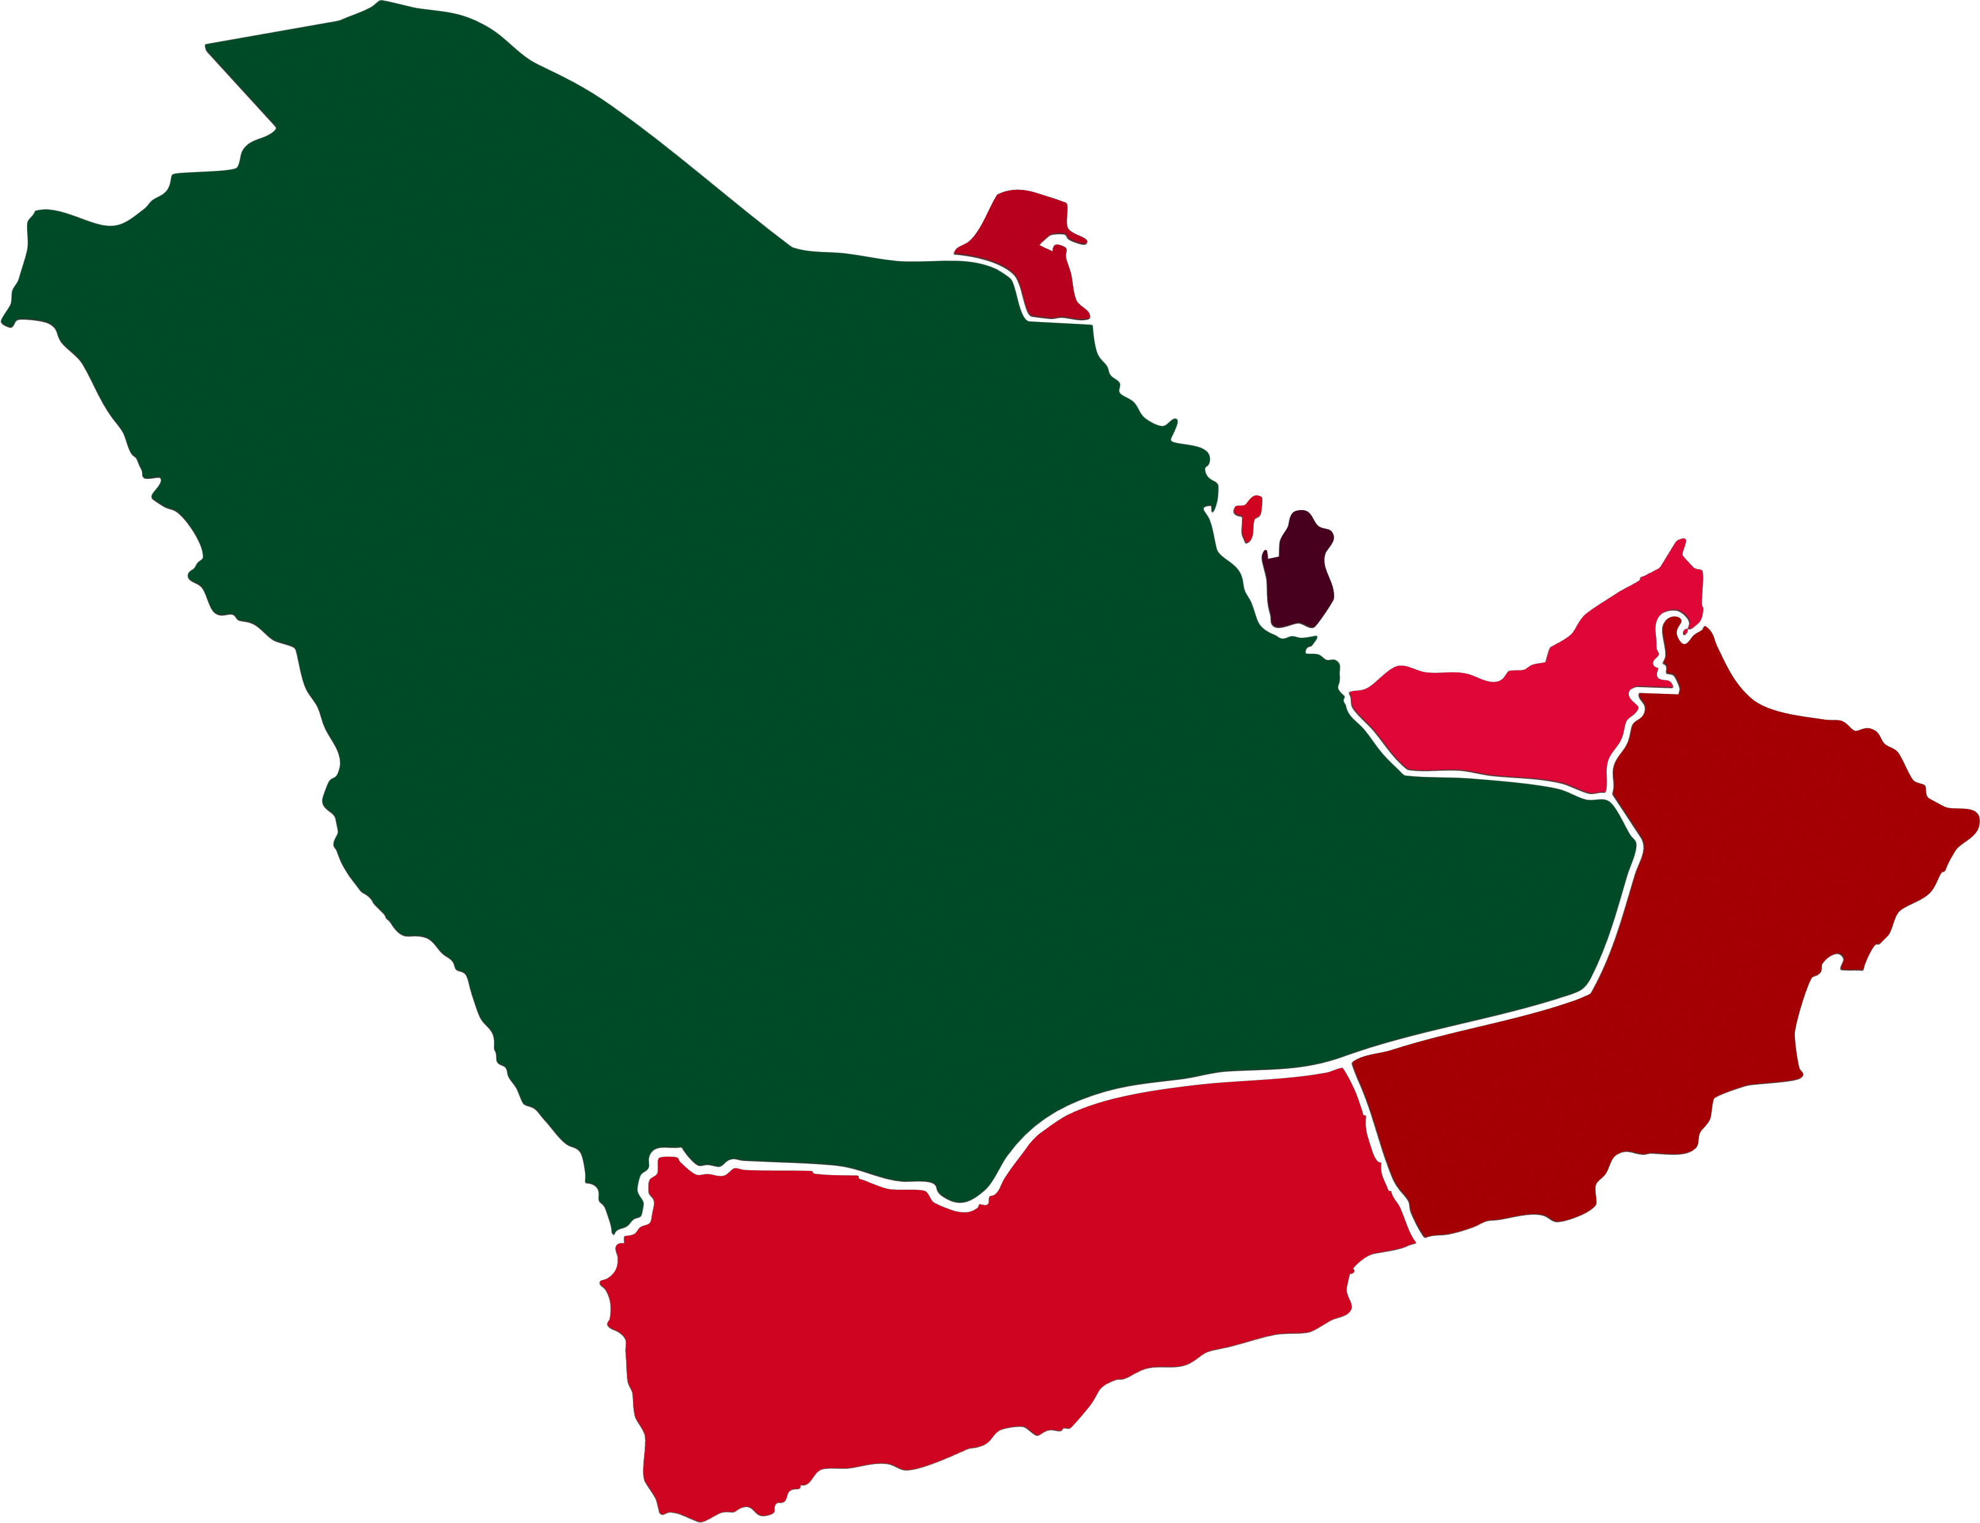Due to extensive requirement by various agents & NVO's in our group as well as lots of local inquiries, We introduce its professional/reliable service to industry in large scale.
  + Our service includes Clearance/Trucking/ofﬂoading of COC reloading on trucking or SOC to UAE & Other GCC Countries.
  + On carriage can be forwarded upon request.

**SAFE DELIVERY IS OUR POLICY**



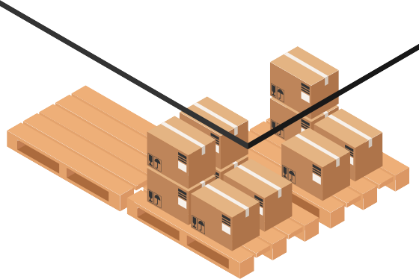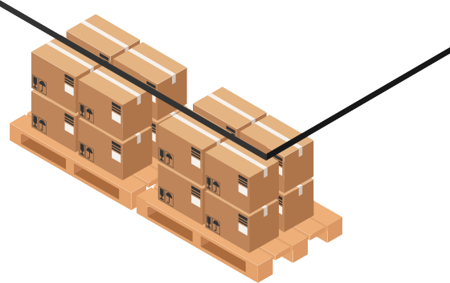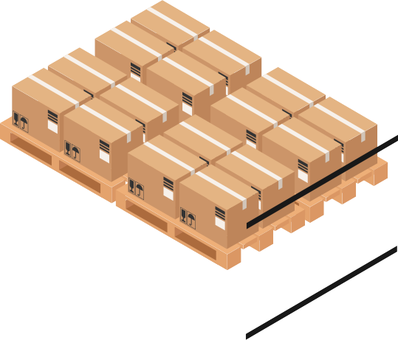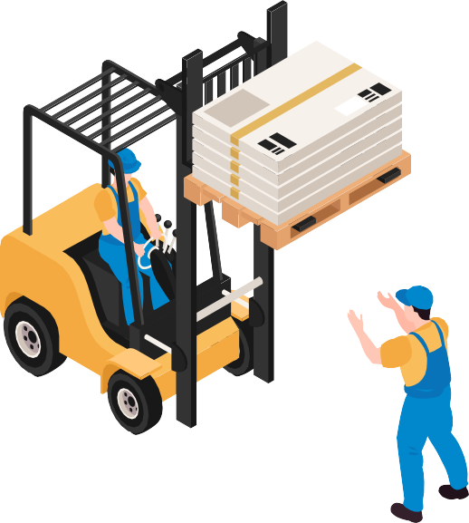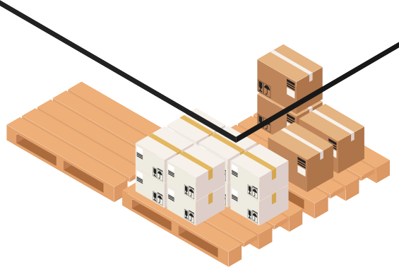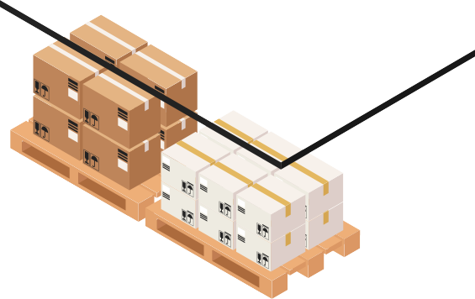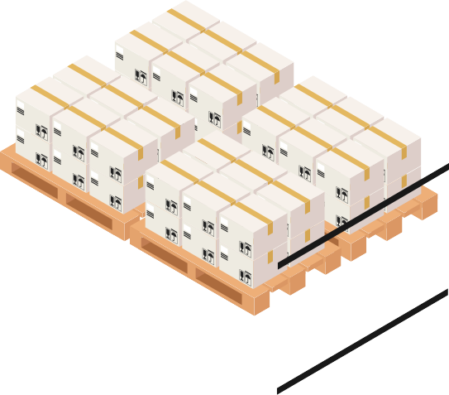

**Warehousing**

With a sprawling network of operational warehouses located across UAE the country can facilitate supply of any product throughout country, SWSS today stands as having one of the leading distribution setup in UAE With its commitment to serve its customers and meet their expectations of time and quality, SWSS designs and strives to maintain its warehousing facilities such that to ensure each unit of every product gets the requisite care in its storage and handling.

The warehouses operations are developed to enable movement of the product through the downstream supply chain in an efficient manner relative to the local market dynamics. Inspired from the best in class systems present, SWSS has developed its own Warehousing Quality Standards

which remains an evolving system. These standards are implemented at each facility along with the requisite training of resources creating a Quality Culture within the organization SWSS considers Quality Assurance as a source of competitive advantage and treats it accordingly. One of the key objectives

of SWSS remains to continuously evaluate and employ the use of

technology to better its service levels and analyse its distributions operational model, consequently making certain that each step involved in the process adds value to the overall supply chain.



**Contact Us:**

[Info@swssgp.com](mailto:Info@swssgp.com)